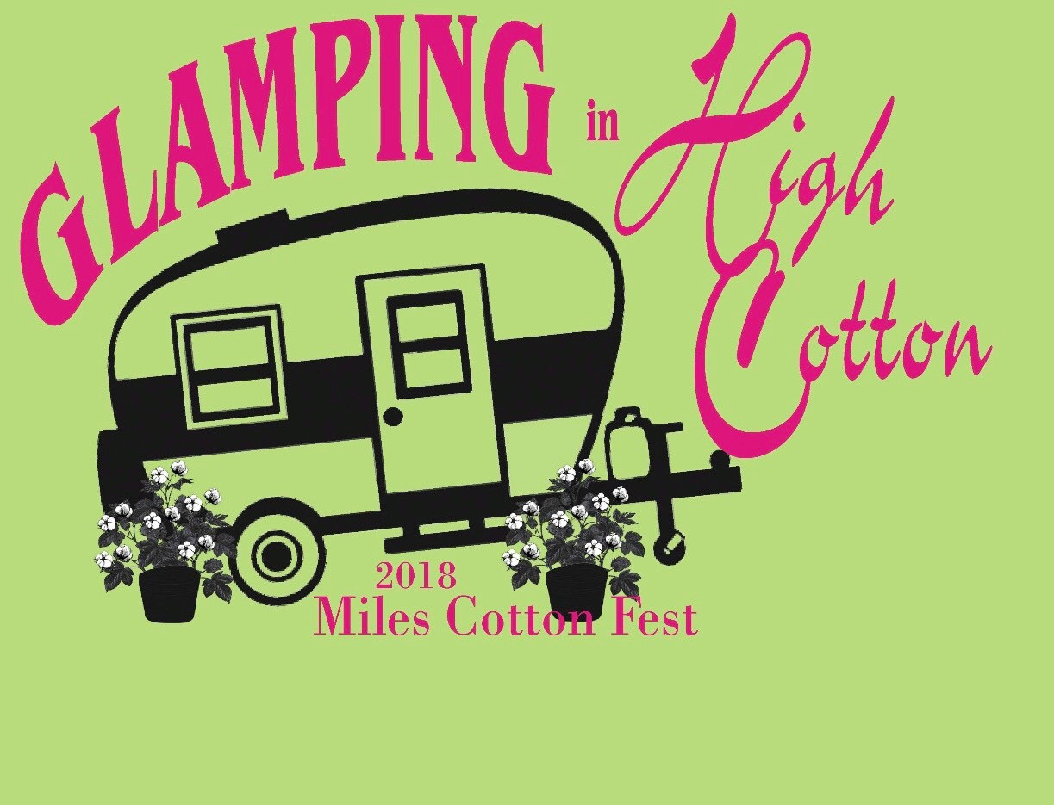

General Information: 9:00am-5:00pm (You are welcome to stay as long as you like)

Set up time: 3PM to 8PM on Friday, September 7th and 7AM to 9AM on Saturday, September 8th. NOTE: There is no security available so if you choose to set up on Friday night, it is at your own risk. Bring shade with you. The park does have some shade, but not enough shade for all booths. If you absolutely do not have shade/tent/awning, please make a note on the application. If you have exhibited before at the Cotton Festival and would like to request the same location as you have had in the past, please make a note below and have your application postmarked by the deadline. We will do our best, but cannot guarantee the same location.

Deadlines:
Deadline for pre-registrations must be postmarked by August 24th, 2018. No refunds after September 3rd, 2018. No Refunds due to inclement weather or no shows. All booths are approximately 10 x 10. **Late entries will have a one time $20.00 dollar late fee

Arts and Crafts Booths: Arts, Crafts, Vintage, Collectibles, Clothing, etc. NO garage sale items or water balloons. If you sell Silly String, then you must advise the buyer to take it away from the craft and food area so that it will not cause damage to other vendors’ merchandise. NO guns that shoot ANYTHING!

Food Booths: The Miles Knights of Columbus pays an exclusive fee to be the only booth that sells barbecue sandwiches, soft drinks and water. Therefore, no other booth may sell barbecue sandwiches, soft drinks or water. If you choose to sell them, you will be asked to leave and no refund will be given. **Also, the number of food booths selling the same items will be limited, requests for booths will be on a first come, first serve basis. **

Any questions please contact:
Amy Fisher – Miles City Hall – 325-468-3151 8 A.M. to 4 P.M. Monday through Friday or Karyn Brown 325-895-0296 after 4:00 P.M. (Cell)
(If no answer at any number above, please leave a message.)
Or you may e-mail questions to Karyn.brown@milesisd.net
Check out our Facebook page @ facebook.com/milescottonfestivalartsandcrafts2018

Miles 2018 Cotton Festival
Arts/Crafts Booth Application

Name__________________________Business Name (if Applicable)_______________________

Address_________________________City__________________State_____Zip____________

Phone (home)___________________________(cell)____________________________________

Nature/Types of products to be sold:

Number of Craft Booths:_________________________________Items to be sold:____________ _______________________________________________________________________________
_______________________________________________________________________________

Are you requesting the same booth space you have had previously? If so, number or description of location:________________________________________________________________________

Do you need shade? There is no guarantee for shade, but will do the best we can._________

***E-mail Address_____________________________________________________________________

**Please mark the all that applies to you: All Booths are approximately 10 x 10.**

Craft Booth, Antiques, Clothing, Other

Postmarked by August 24th --------------------------$30.00 per 11 x 10 booth______________
Postmarked after August 24th -----------------------$50.00 per 10 x 10 booth______________
Electricity---------------------------------------------------------------------$10.00______________
Late fee------------------------------------------------------------------------$20.00______________

Total CRAFT dues enclosed_________________

SALES TAX NUMBER:______________________________________________

Mail to: MPA Arts & Crafts
202 Clover
San Angelo, Tx. 76903 **Make checks payable to MPA (Miles Preservation Authority)

Miles 2018 Cotton Festival
Food Booth Application

Name__________________________Business Name (if Applicable)_______________________

Address_________________________City__________________State_____Zip____________

Phone (home)___________________________(cell)____________________________________

Are you requesting the same booth space you have had previously? If so, number or description of location:________________________________________________________________________

Do you need shade? There is no guarantee for shade, but will do the best we can._________

***E-mail Address_____________________________________________________________________

**Please mark the all that applies to you: All Booths are approximately 10 x 10.**

**Please note the length of your trailer INCLUDING tongue = ___________
Please be accurate - This measurement is very important in the planning of lining up trailers

Number of Food Booths_________________________________Food Items to be sold:________ _____________________________________________________________________________________________________________________________________________________________________________________________________________________________________________

(If your trailer exceeds more than 10 feet you must get 2 booths/20 feet – 3 booths)

Postmarked by August 19th ----------------------------------$35.00 per 10 x 10 booth______________
Postmarked after August 19th --------------------------------$55.00 per 10 x 10 booth______________
Electricity-----------------------------------------------------------------------------$10.00______________
Late Fee-------------------------------------------------------------------------------$20.00______________

Total FOOD dues enclosed__________________

SALES TAX NUMBER:______________________________________________

Mail to: MPA Arts & Crafts
202 Clover
San Angelo, Tx. 76903 **Make checks payable to MPA (Miles Preservation Authority)

